**Revitalizing a Struggling Food Truck Business into a Thriving Operation**

**Role**: CEO & Founder  
**Project Date**: 2019  
**Industry**: Food & Beverage

**Table of Contents**

1. **Introduction**
2. **Problem Statement**
3. **Research and Data Collection**
   1. Awareness of the Food Truck
   2. Customer Experience
   3. Actionable Insights
4. **Strategies and Solutions Implemented**
   1. Visual Revamp of the Food Truck
   2. Expansion of Target Market
   3. Product Offering Improvement: Introduction of Platter System
   4. Building Customer Trust: Pay-After-Eating Policy
   5. Innovative Digital Marketing: QR Code Campaign
5. **Results & Analysis**
   1. Revenue Growth
   2. Customer Base Expansion
   3. Repeat Business
6. **Data Visualization: Dashboards**
   1. Market Research Insights Dashboard
   2. Sales Growth Dashboard
   3. Customer Demographics Dashboard
   4. Trust-Building & QR Code Campaign Impact
7. **Conclusion**

# 1. Introduction

Starting a food truck business seemed like an exciting venture, especially with the potential to offer unique street food experiences. However, I quickly realized that initial enthusiasm wasn't enough to turn a profit. After investing ₹5000 per day, my daily sales barely reached ₹1500. This financial loss, coupled with low visibility and customer traction, made me realize I needed to make immediate changes. Through in-depth research and analysis, I identified the core issues and implemented innovative strategies that eventually tripled my revenue.

This project outlines my journey, highlighting the challenges, solutions, and growth strategies that led to the transformation of my food truck business.

# 2. Problem Statement

Despite the significant daily investment of ₹5000, the business failed to generate enough revenue, resulting in daily sales of only ₹1500. I struggled to draw customers, and those who visited the truck offered mixed feedback, with concerns primarily about the quantity and appearance of the shop. I needed a clear strategy to:

* Increase customer awareness.
* Improve customer satisfaction.
* Enhance the food truck’s visual appeal.
* Build trust with potential customers.

These were the core challenges that needed addressing.

# 3. Research and Data Collection

Recognizing the need to understand the market and customer preferences better, I decided to conduct a customer-focused research study. This research aimed to identify the reasons behind the low sales and the lack of traction. I began by surveying people around the truck, both existing and potential customers.

## Key Findings from the Research:

1. **Awareness of the Food Truck:**
   * 80% of people surveyed were unaware of the existence of the food truck. This showed that my marketing efforts were insufficient.
   * Only 20% of people had any knowledge about the business.
2. **Customer Experience:**
   * Of the 20% who knew about the food truck, 50% had tried the food, while the other 50% had not.
   * Of those who tried the food, half of them liked the taste but expressed dissatisfaction with the portion sizes, noting that the portions were too small.
   * The 50% who hadn't tried the food cited the truck's unappealing appearance as the main reason for avoiding it.
3. **Actionable Insights:**
   * I needed to address three primary areas: **marketing**, **product offering**, and **shop aesthetics**.
   * My business required a **customer-centric** approach to better meet consumer expectations while simultaneously drawing more attention to the shop.

# 4. Strategies and Solutions Implemented

After analyzing the research data, I developed a comprehensive action plan to address the core problems.

## 4.1. Visual Revamp of the Food Truck

**Problem Identified:**  
50% of potential customers mentioned the truck’s unappealing appearance as a reason for not trying the food.

**Solution:**  
I invested in redesigning the exterior of the truck, making it visually attractive to pedestrians and passersby. The new design featured bright colors, artistic graphics, and appealing signage that reflected the food offerings. This visual improvement helped increase foot traffic significantly.

**Outcome:**  
The improved aesthetic appeal drew more customers to the food truck, making it look more inviting and aligning the truck’s appearance with the quality of food served.

## 4.2. Expansion of Target Market

**Problem Identified:**  
The initial target market was too narrow, focused on customers in the immediate area.

**Solution:**  
I broadened the target market from just the local area to the entire city. The new target audience included individuals aged 16-40, expanding the demographic and increasing the potential customer base. Additionally, I created city-wide marketing campaigns, using local influencers and social media to spread the word about the food truck.

**Outcome:**  
This market expansion strategy widened the customer base, leading to an increase in daily visitors, many of whom traveled from different parts of the city to try the food.

## 4.3. Product Offering Improvement: Introduction of Platter System

**Problem Identified:**  
Customers complained about the portion sizes being too small, which negatively impacted their overall satisfaction.

**Solution:**  
To address this, I introduced a **Platter System** where customers could sample a variety of dishes in one platter at an affordable price. The platters were designed to be filling and diverse, offering something for everyone.

**Outcome:**  
The new platter system became a hit among customers, who appreciated the variety and value for money. This change led to higher customer satisfaction and increased repeat business.

## 4.4. Building Customer Trust: Pay-After-Eating Policy

**Problem Identified:**  
There was a lack of trust from potential customers, who were hesitant to try the food due to concerns about quality.

**Solution:**  
To build trust with new customers, I introduced a policy where customers could eat first and pay later if they were satisfied. This reduced the barrier to trying the food and reassured customers about the quality of the service and product.

**Outcome:**  
This initiative not only brought in new customers but also increased word-of-mouth referrals as people began to trust the business more. Trust and customer satisfaction soared, leading to higher retention rates.

## 4.5. Innovative Digital Marketing: QR Code Campaign

**Problem Identified:**  
80% of people were unaware of the food truck, highlighting the need for a stronger marketing strategy.

**Solution:**  
I introduced a **QR-code-based marketing strategy**. Customers who scanned the QR code from the truck received a free meal if they provided feedback and shared their experience on social media. This digital word-of-mouth marketing method generated buzz and led to organic growth as more people discovered the business through their friends’ social media posts.

**Outcome:**  
The campaign led to a surge in social media engagement, with numerous people posting about their positive experiences. Awareness of the food truck increased dramatically, and customer inflow from various parts of the city grew significantly.

# 5. Results & Analysis

The implementation of these strategies yielded significant positive results.

**Key Metrics:**

* **Revenue Growth**: Daily sales increased from ₹1500 to over ₹5000, tripling the original revenue.
* **Customer Base Expansion**: The new strategies brought in customers from different areas of the city, and the target age range (16-40) became more inclusive.
* **Repeat Business**: The customer retention rate increased from 20% to 60%, as people trusted the business more and enjoyed the new offerings.

**Data-Driven Insights:**

To track the performance of my strategies, I utilized dashboards to monitor key metrics such as sales growth, customer demographics, and feedback trends. Below are visual representations of the results achieved:

# 6. Data Visualization: Dashboards

## 6.1. Market Research Insights Dashboard

This dashboard presents the research findings, showcasing the low awareness of the food truck (80% unaware) and customer feedback regarding taste and portion sizes. (*Excel Pivotal)*

*Figure 6:1:1*

*Figure 6:1:2*

*Figure 6:1:3*

*Figure 6:1:4*

## 6.2. Sales Growth Dashboard

A line graph showing the significant increase in daily sales after implementing the strategies, with sales climbing from ₹1500 to over ₹5000 in a few weeks. (*Power BI)*

*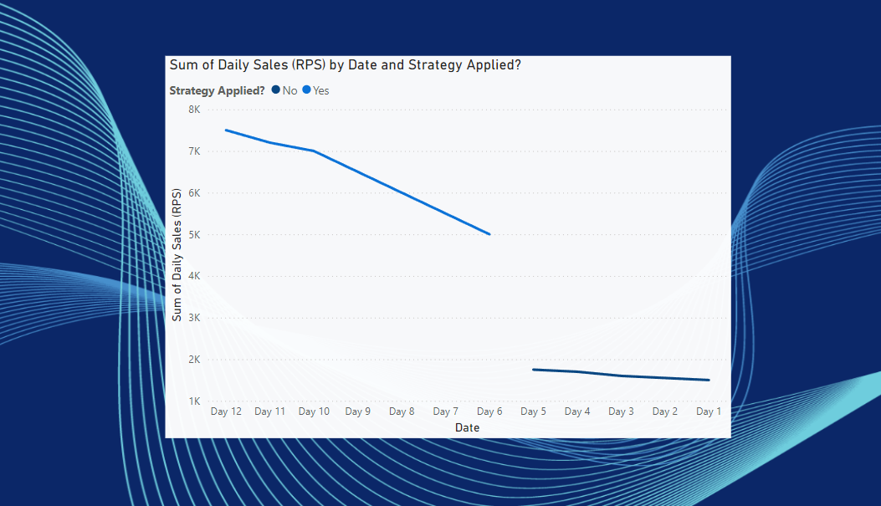Figure 6:2:1*

## 6.3. Customer Demographics Dashboard

A breakdown of customer demographics post-expansion, showing the wider age range (16-40) and the geographic diversity of customers visiting the truck. (*Tableau*)

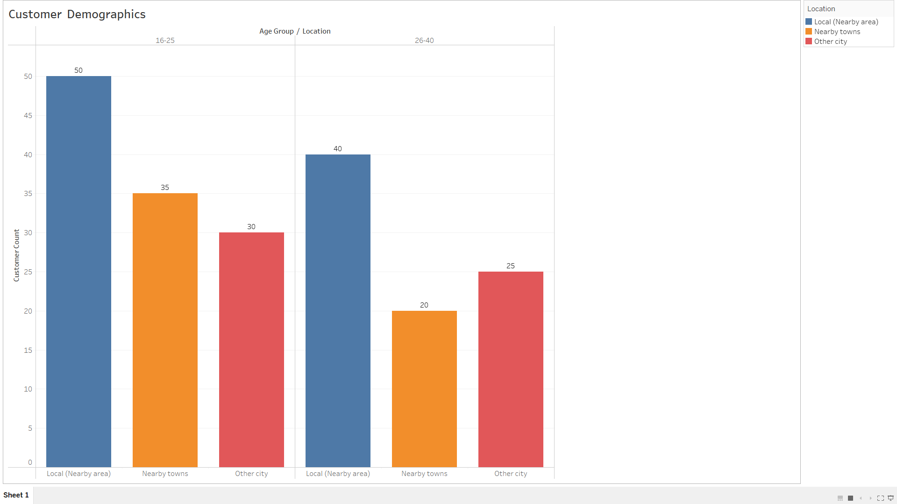*Figure 6:3:1*

## 6.4. Trust-Building & QR Code Campaign Impact

A Before and After campaign metrics analysis of the strategies I applied demonstrates a notable increase in customer awareness, satisfaction, and revenue.

|  |  |  |
| --- | --- | --- |
| **Metric** | **Before Campaign** | **After Campaign** |
| Customers Participating (Per Day) | 0 | 15 |
| Social Media Shares | 0 | 35 |
| Free Meals Given (Per Day) | 0 | 10 |
| Increase in Sales due to QR Campaign (%) | 0% | 25% |

*Figure 6:4:1*

# 7. Conclusion

Through a combination of strategic marketing, operational changes, and a customer-centric approach, I was able to turn a struggling food truck into a thriving business. The success was driven by data insights, customer feedback, and the implementation of creative marketing solutions, which resulted in a threefold increase in revenue and a growing, loyal customer base.